ASSIGNMENT :3

### Counting Elements

Program:

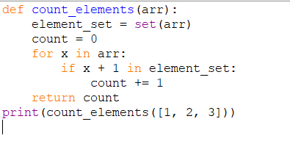

Output:



### 2. Perform String Shifts

Program:

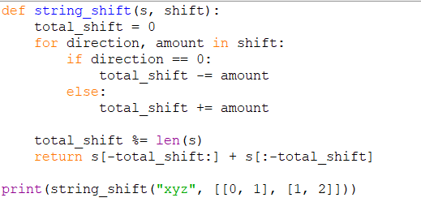

Output:



### 3. Leftmost Column with at Least a One

Program:

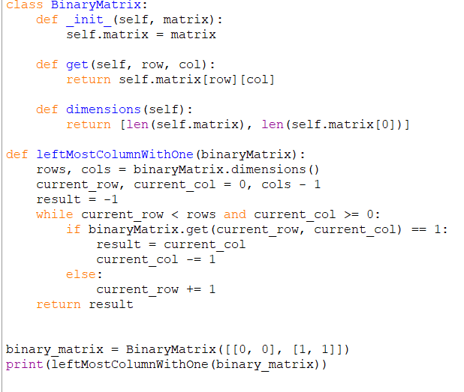

Output:



### 4. First Unique Number

Program:

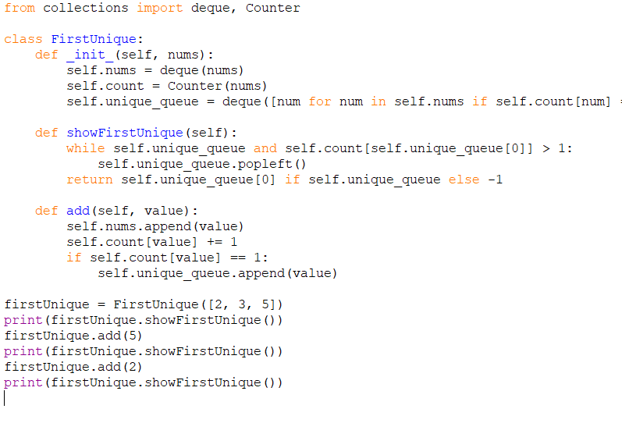

Output:

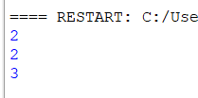

### 5. Check If a String Is a Valid Sequence from Root to Leaves Path in a Binary Tree

Program: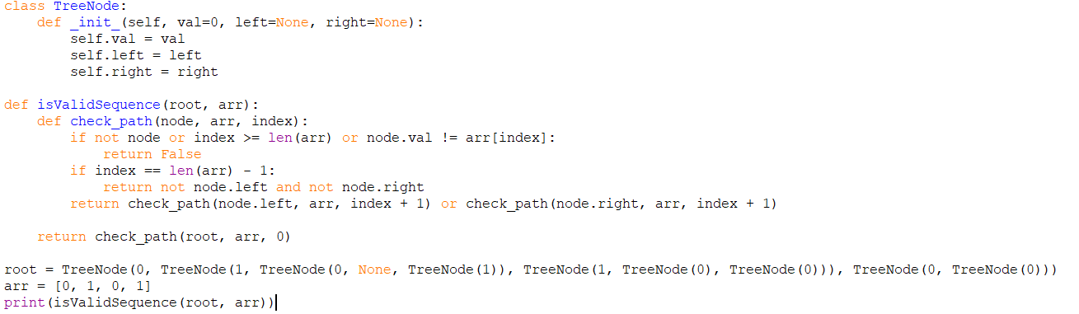

Output:



### 6. Kids With the Greatest Number of Candies

Program: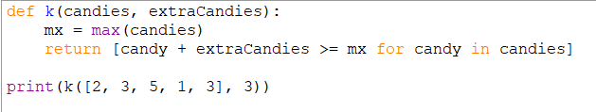

Output:



### 7. Max Difference You Can Get From Changing an Integer

Program:

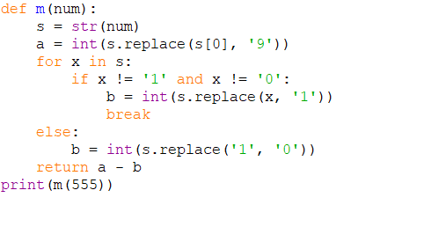

Output:



### 8. Check If a String Can Break Another String

Program:

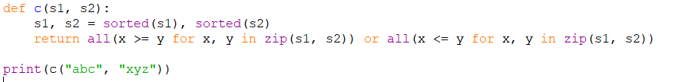

Output:

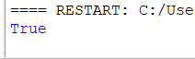

### 9. Number of Ways to Wear Different Hats to Each Other

Program:

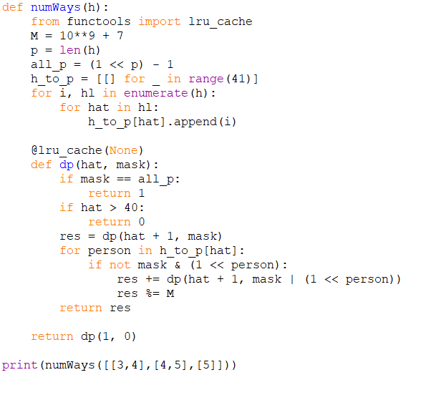

Output:



### 10. Next Permutation

Program:

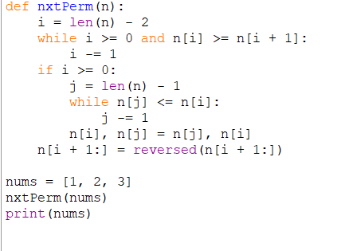

Output:

